**College Management System**



**A**

**Project Report On**

**“COLLEGE MANAGEMENT SYSTEM”**

**Submitted to**

**SAVITRIBAI PHULE UNIVERSITY**

**In partial fulfilment of the Requirement of**

Bachelor of Business Administration

(Computer Application)

(Semester – V)

**Submitted By**

**Mr.Shubham Pund**

**Mr.Avishkar Tapkir**

**Under the guidance of**

Prof.Mrs.Bhagyashri R. Joshi

**DEPARTMENT OF B.B.A(C.A)**

**CERTIFICATE**

**This is to certify that Mr Shubham Pund & Mr Avishkar Tapkir**

**of class B.B.A(C.A)(SemesterV) have**

**Completed the project work on**

**“COLLEGE MANAGEMENT SYSTEM”**

**Under my guidance & supervision in a satisfactory manner for the Practical fulfilment of BCA III(V) examination for the academic year 2022-2023.**

**Dr. Balvant landge Prof. Sanjay Gaikwad**

**(Incharge) (Principle of College)**

**Project Guide Internal Examiner External Examiner Mrs.B.R.Joshi**

**Date:**

**Place:**

**INDEX**

|  |  |  |
| --- | --- | --- |
| **Sr. No** | **Name** | **Page** |
| **1)** | **Introduction**  **1.1) Introduction to system**  **1.2) Acknowledgement** | **5-6** |
| **2)** | **Existing System**  **2.1)Existing System**  **2.2) Fact Finding Technique**  **2.2) Advantages of System**  **2.3) Disadvantages of System** | **7-8** |
| **3)** | **Proposed system**  **3.1) Hardware & Software Specification**  **3.2) Feasibility Study**  **3.3) Proposed System**  **3.4) Objective of Proposed System**  **3.5) Scope of Proposed System** | **9-11** |
| **4)** | **System Analysis**  **4.1) ERD**  **4.2) Context Level DFD**  **4.3) First Level DFD**  **4.4) Use Case Diagram**  **4.5) Class Diagram**  **4.6) Activity Diagram**  **4.7) Sequence Diagram** | **12-20** |
| **5)** | **System Design**  **5.1) Table Design**  **5.2) User Interface**  **5.2.1) Input Design Form**  **5.2.2) Output Design Reports** | **21-24** |
| **6)** | **Future Enhancement** | **25** |
| **7)** | **Bibliography** | **26** |

**Introduction**

* **College Management System is a complete school information management solution.**
* **Product line and customization service allow our customers to satisfy any business needs.**
* **We developed our program to ensure that you will get familiar with our software in the absolute minimum time. We made the installation process as clear as possible.**
* **It does not require any special knowledge or efforts.**
* **We bundle our software with full customer support. Our experts are always ready to answer questions. We always offer customization services.**
* **We can customize the software to completely fit the structure of your business.**

**ACKNOWLEDGEMENT**

We express our profuse thanks to our Guide

Mrs. B.R..Joshi

We wish to express our thanks to respected teachers and all teaching staff who have been a constant source of encouragement and assistance.

Last but not least, we are also grateful to College Library, Computer Lab and workshop facilities made available by our college. I also express my thanks to all my friends & specially my relative who helped me directly or indirectly in preparation of this project.

**EXISITING SYSTEM**

TheRegional office have different designation employees in the office to manage all the work.

* The chief is the regional transport officer.
* If there are many employee in the office to carry the work.

**Fact Finding Technique**

* Interviewing the institute’s owner for collecting information about institute’s process.
* Interviewing and filling questionnaires by faculty who regarding process.

**ADVANTAGE AND DRAWBACK**:

* **Advantages of system:**
* Accuracy:

The level of accuracy in the proposed system will be higher. All operation would be done correctly and it ensures that whatever information is coming from the center is accurate.

* Reliability:

The reliability of the proposed system will be high due to the above stated reasons. The reason for the increased reliability of the system is that now there would be proper storage of information.

* No Redundancy:

In the proposed system at most care would be that no information is repeated

anywhere, in storage or otherwise. This would assure economic use of storage space and consistency in the data stored.

* Immediate retrieval of information:

The main objective of proposed system is to provide for a quick and efficient

retrieval of information. Any type of information would be available whenever the user requires.

* Immediate storage of information:

In manual system there are many problems to store the largest amount of Information.

* Easy to Operate:

The system should be easy to operate and should be such that it can be developed within a short period of time and fit in the limited budget of the use

* **Disadvantages of system:**
* Lack of immediate retrievals:
* Lack of immediate information storage:
* Lack of prompt updating:
* Error prone manual calculation:
* preparation of accurate and prompt reports:

**PROPOSED SYSTEM**

* **HARDWARE AND SOFTWARE REQUIREMENT:**

To install and run the proposed system the following hardware and software is

required.

* **Hardware Requirement :-**

• Processor : Intel Dual- Core and onwards

• Primary memory (RAM) : 1 GB and onwards

• Secondary memory (Hard Disk) : 160 GB onwards

• Printer : HP Desk Jet D2568 other

* **Software Requirement:-**

• Operating System : Microsoft Windows XP 2002

• Front-End : Visual Basic 6.0

* **FEASIBILITY STUDY OF THE SYSTEM:**
* Depending on the results of the initial investigation the survey is now expanded to a

more detailed feasibility study. “FEASIBILITY STUDY” is a test of system proposal

according to its Workability, impact of the organization, ability to meet needs and

Effective use of the resources.

It focuses on these major questions:

* What are the user’s demonstrable needs and how does a candidate system meet them?
* What resources are available for given candidate system?
* What are the likely impacts of the candidate system on the organization?
* Whether it is worth to solve the problem?

During feasibility analysis for this project, following primary areas of interests are

to be considered. Investigation and generating ideas about a new system does this.

* **TECHNICAL FEASIBILITY:**
* A Study of resource availability that may affect the ability to achieve an acceptable

system. This evaluation determines whether the technology needed for the proposed system

is available or not. 1. Can the work for the project be done with current equipment existing software

technology& available personal?

* Can the system be upgraded if developed?
* If new technology is needed then what can be developed?

This is concerned with specifying equipment and software that will successfully satisfaction.

* **ECONOMICAL FEASIBILITY**

Economic justification is generally the “Bottom Line” consideration for most

systems. Economic justification includes a broad range of concerns that includes cost

benefit analysis. In this we weight the cost and the benefits associated with the candidate

system and if it suits the basic purpose of the organization i.e. profit making, the project is

making to the analysis and design phase. The financial and the economic questions

during the preliminary investigation are verified to

estimate the following:

• The cost to conduct a full system investigation.

• The cost of hardware and software for the class of application

being considered.

• The benefits in the form of reduced cost.

• The proposed system will give the minute information, as a result

the performance is improved which in turn may be expected to

provide increased profits.

• This feasibility checks whether the system can be developed with the available funds.

The SMS does not require enormous amount of money to be developed. This can be

done economically if planned judicially, so it is economically feasible.

* **OPERATIONAL FEASILBILITY**

It is mainly related to human organizations and political aspects.

The points to be considered are:

• What changes will be brought with the system?

• What organization structures are disturbed?

• What new skills will be required?

Do the existing staff members have these skills? If not, can they be trained in due

course of time?

The system is operationally feasible as it very easy for the End users to operate it. It

only needs basic information about Windows platform.

* **PROPOSED SYSTEM**

SMS is a School Management system developed for All school.

This software targets to provide complete solution for School and related services.

The main features of Common:-

* Maintaining Student Details.
* Maintaining Employees Details.
* Providing & Maintaining Teacher Details.
* **SCOPE OF THE PROPOSED SYSTEM**
* It can be used in any School, Colleges, or Institutes for maintaining Student,

Teacher & Employee details and their Salaries.

* Billing and payments ,
* Security of the whole system,
* Staff management (Teacher, Peon, Clerk, etc )
* Management functions (report generation, accounting, etc )
* Student registration,
* System administration,

**SYSTEM**

**ANALYSIS**

**ERD Diagram**

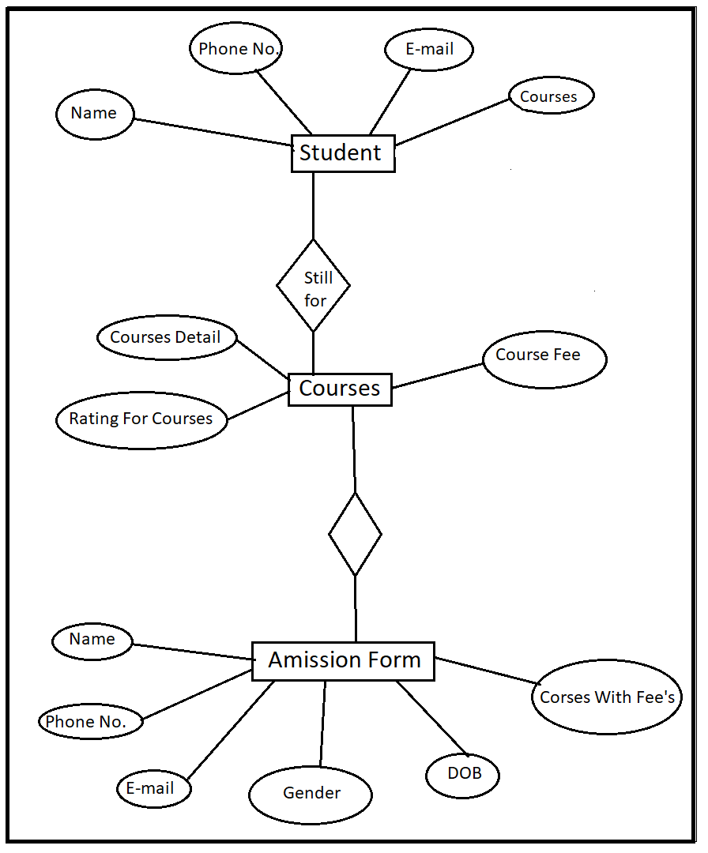

**Context Level Data Flow Diagram**

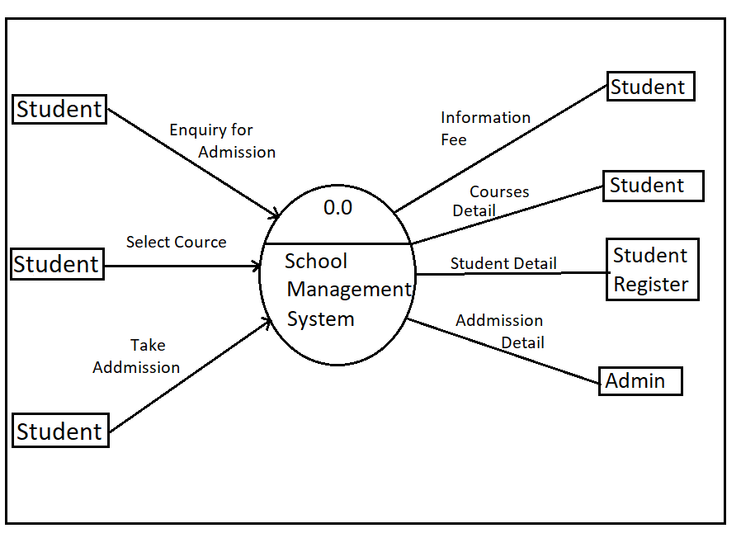

**First level Data Flow Diagram**

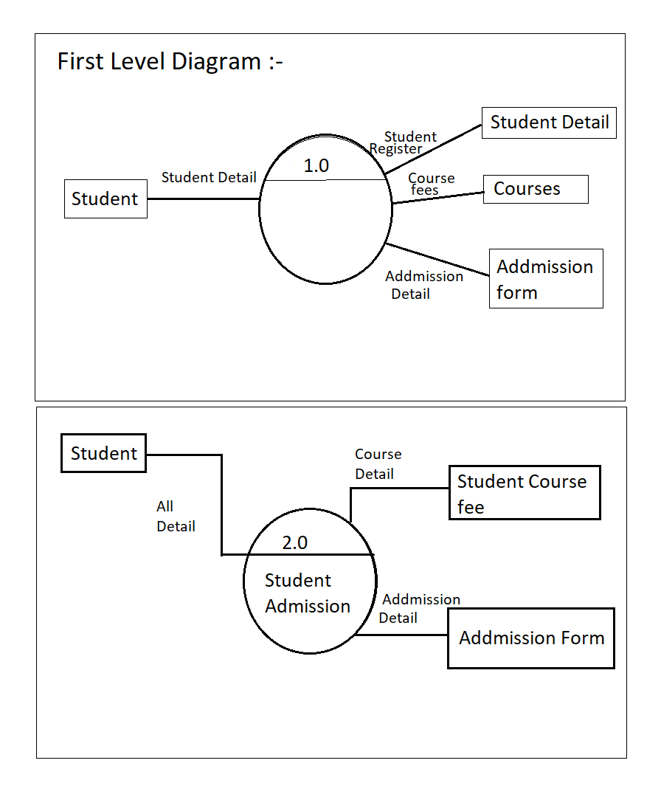

**UML**

**DIAGRAM**

**Use Case Diagram**

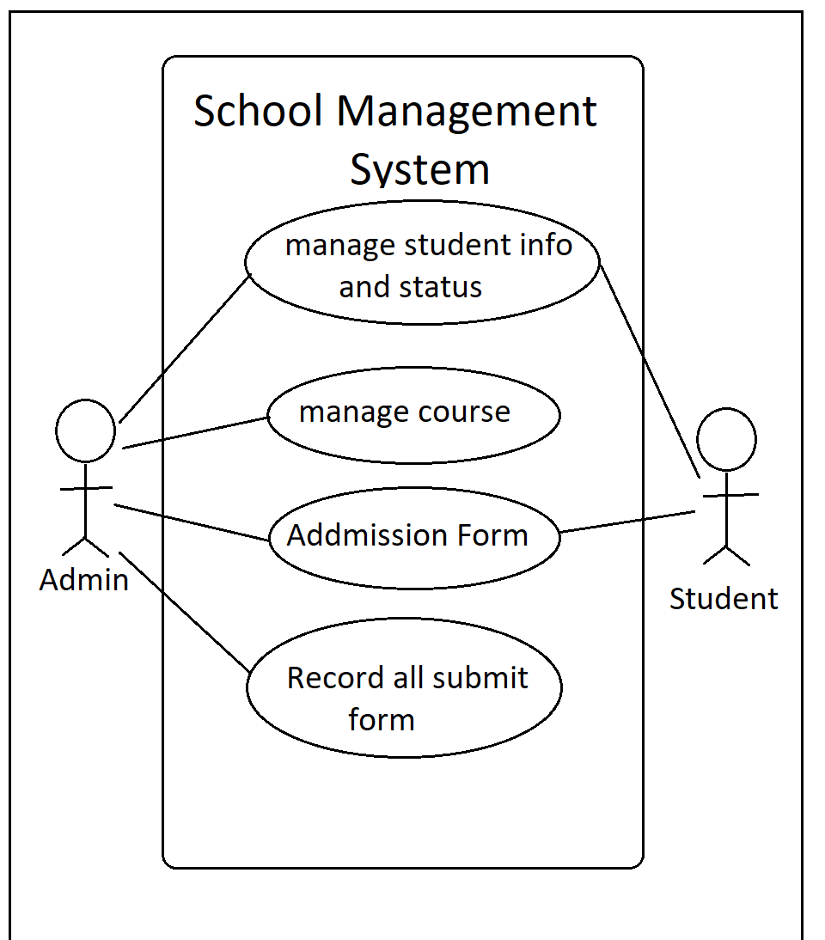

**Class Diagram**

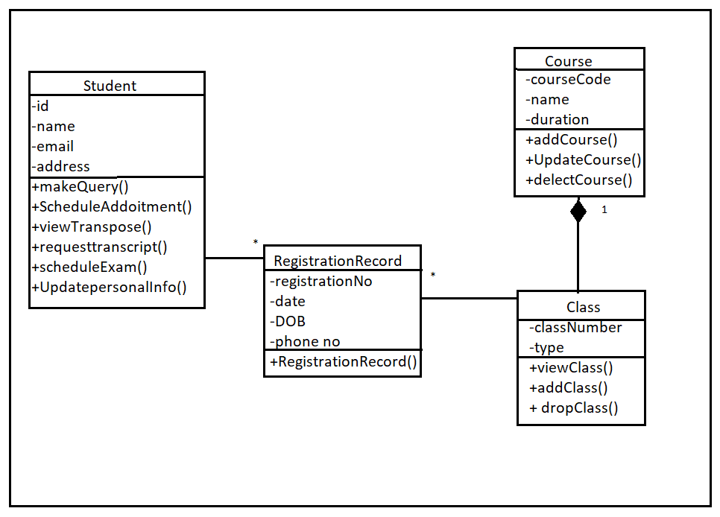

**Activity Diagram**

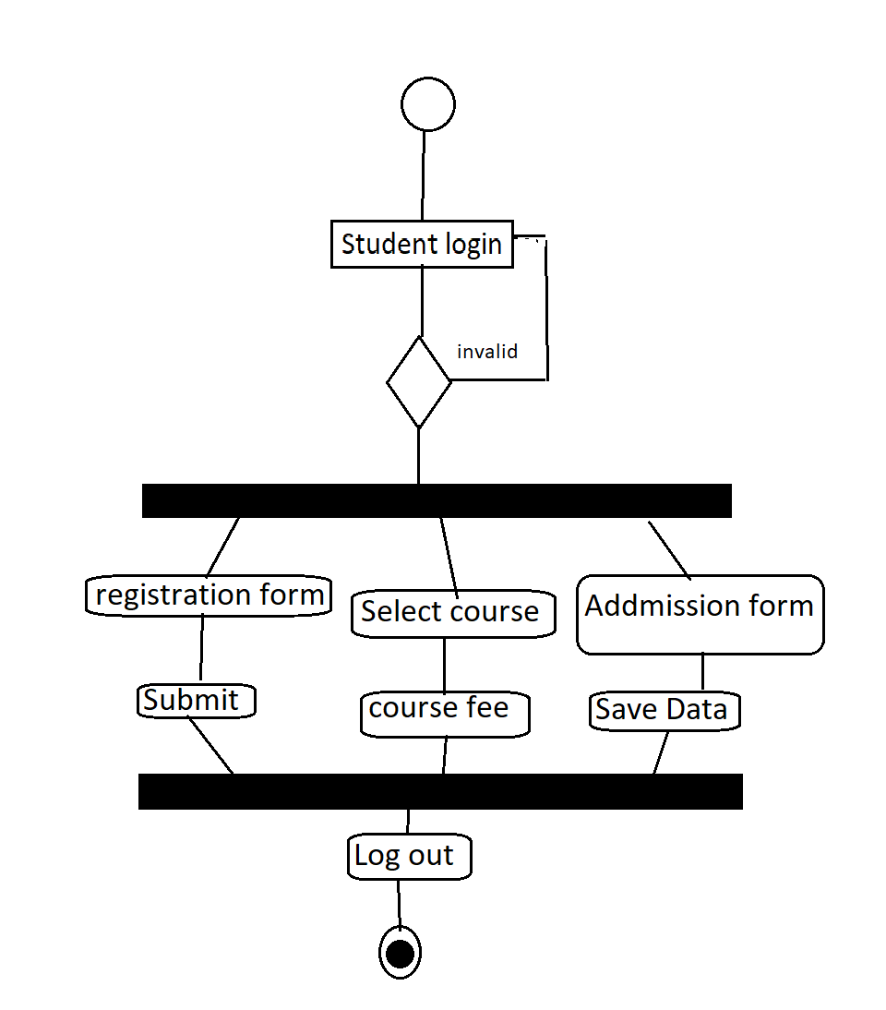

**Sequance Diagram**

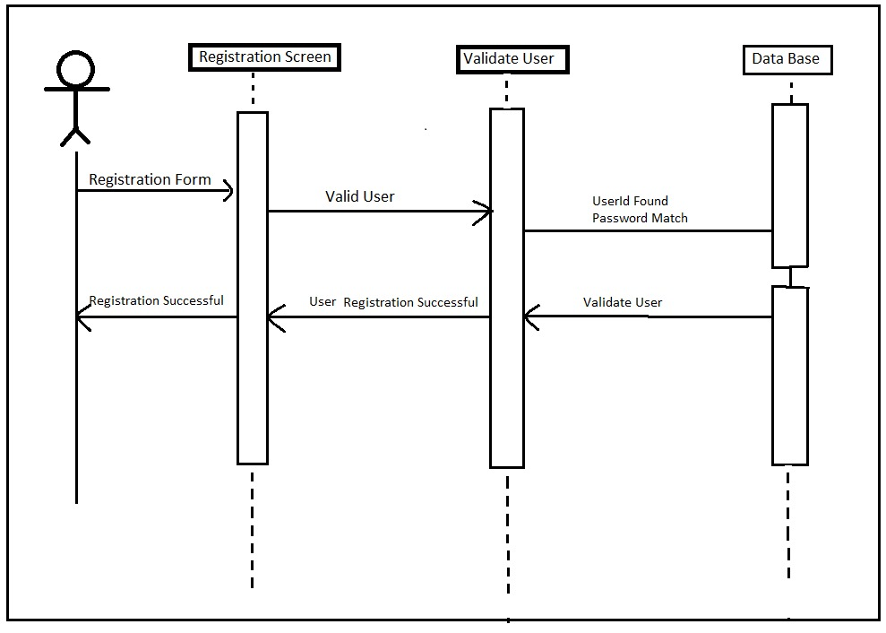

**System**

**Design**

**Table Design**

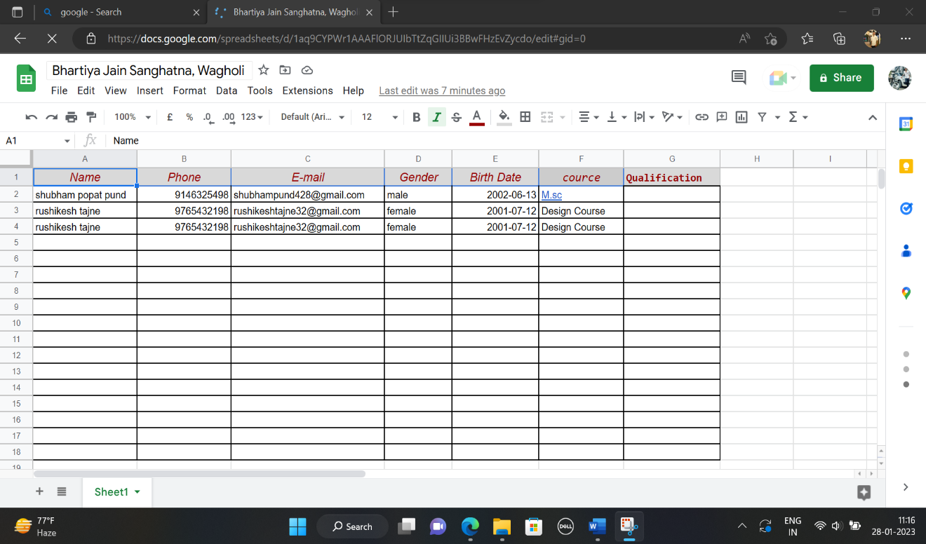

**User Interface**

* **Input Design Form**

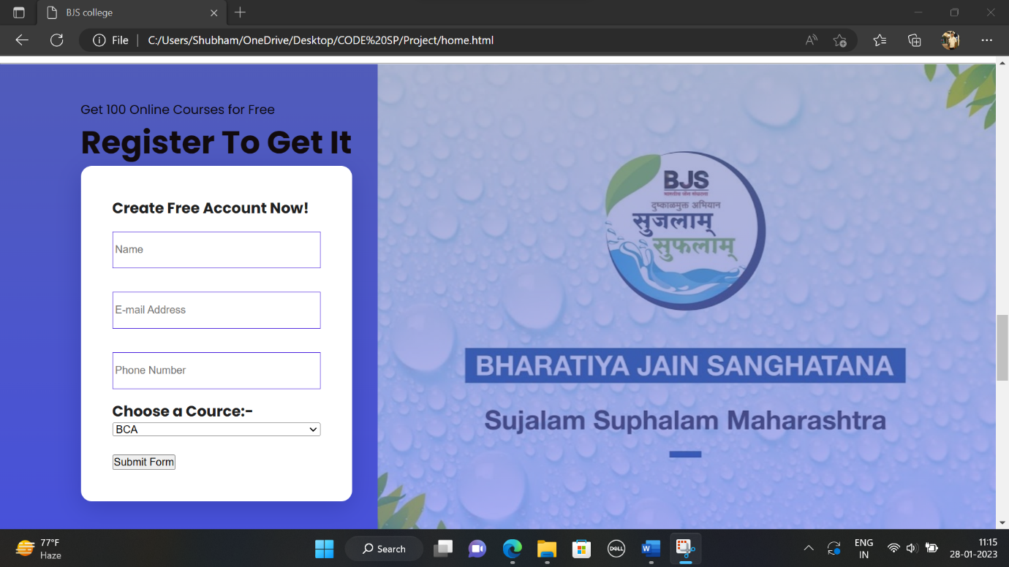

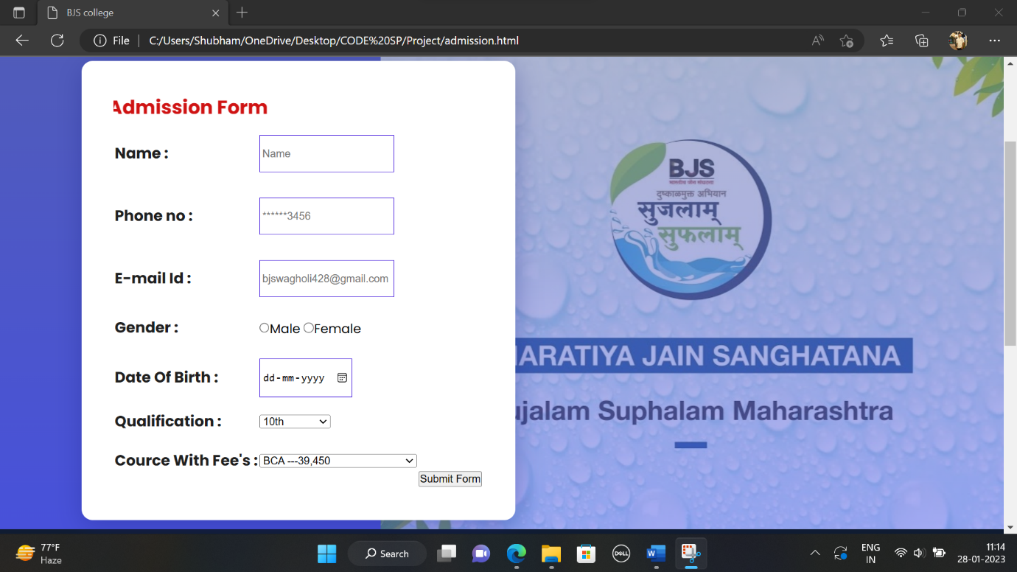

**Output Design Reports**

* **Output Design Reports**

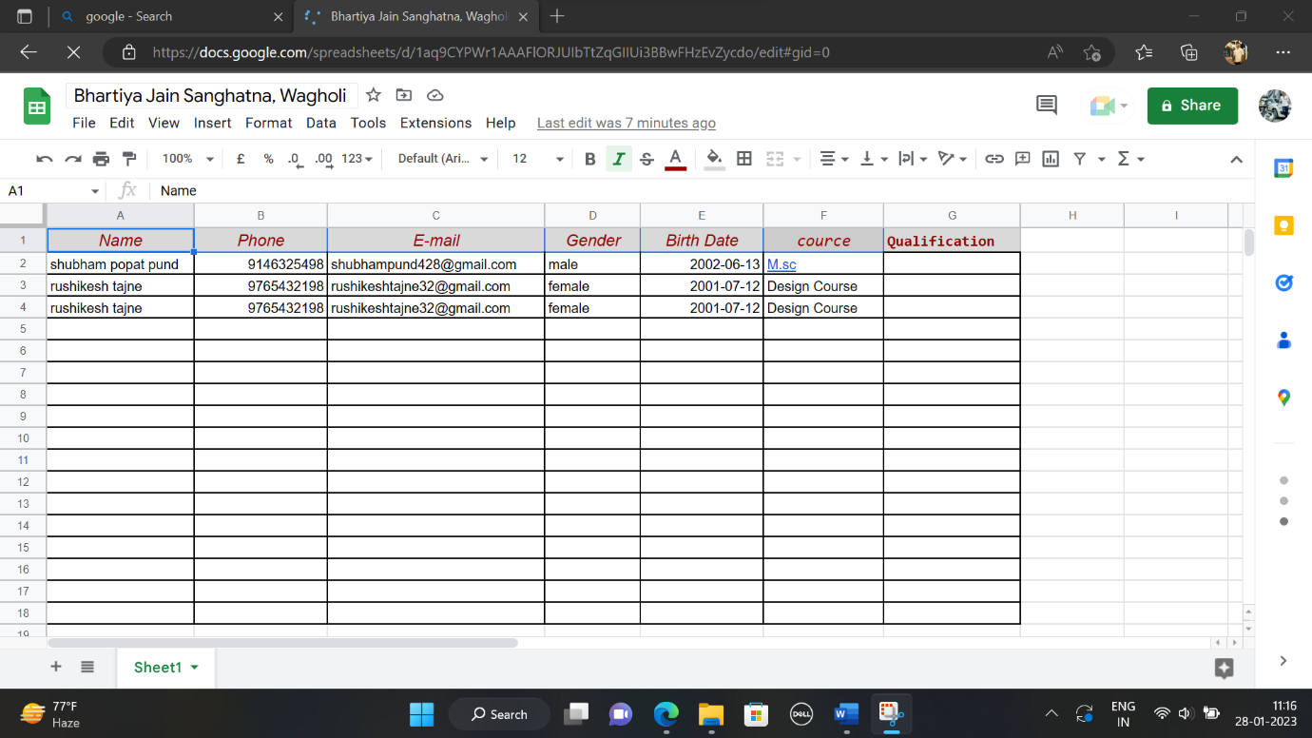

**Future Enhancement** :

* **IN THE FUTURE THE STUDENT CAN ALSO BE ABLE TO UPLOAD OR DOWNLOAD NOTES.**
* **A FEW MORE MONOR TWEAKS HERE AN THERE FOR MARKING THE APPLICATION MORE VISUALLY APPEALING AND WILL HAVE STATISTICS, TRACKING AND ANALYTICS.**
* **THE WHOLE PROJECT WILL BE MADE AVAILABLE AS AN ANDROUND APP FOR MORE EASY OF USE AND MOBILITY**

**Bibliography:**

[**www.google.com**](http://www.google.com/)

[**www.Developervb.net**](http://www.developervb.net/)

[**www.w3school.com**](http://www.w3school.com)

[**www.formspree.com**](http://www.formspree.com)

**Books Referred:-**

**VS Black Book**

**Software Engineering**

***Thank you***